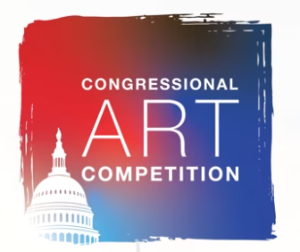
Guidelines:
  - The deadline for the District Office to receive artwork is March 28th.
  - Students can only submit 1 (one) piece of art.
  - Competition is geared towards 9th to 12th grade students who reside in the District of Columbia unless the school has a 7th to 12th grade program.
  - Art must be two-dimensional.
  - It cannot be larger than 26 inches high, 26 inches wide, and 4 inches deep (including the frame once the winner is chosen).
  - No framed piece should weigh more than 15 pounds
  - Accepted mediums for two dimensional are:
    - Paintings: oil, acrylics, watercolor, etc.
    - Drawings: colored pencil, pencil, ink, marker, pastels, charcoal (it is recommended that charcoal and pastel drawings be fixed).
    - Prints: lithographs, silk screen, block prints
    - Mixed Media: use of more than two mediums such as pencil, ink, watercolor, etc.
    - Collages (must be two-dimensional)
    - Computer-generated art
    - Photographs
  - Each entry must be original in concept, design, and execution and may not violate U.S. copyright laws. Any entry that has been copied from an existing photo or image (including a painting, graphic, or advertisement), that was created by someone other than the student is a violation of the competition rules and will not be accepted.
  - Work entered must be in the original medium (that is, not a scanned reproduction of a painting or drawing).
  - Artwork must adhere to the policy of the House Office Building Commission. In accordance with this policy, exhibits depicting subjects of contemporary political controversy or a sensationalistic or gruesome nature are not allowed.
  - The online submission must include a single entry and a completed Student Information & Release Form. No entry will be considered submitted without a completed Student Information & Release Form (including all signatures from student, parent/guardian and art teacher).

